Implementation of an Artificial Intelligence Driven Smart Traffic Management System for Urban Congestion Mitigation.

Aditya Sharma
Student
Presidency School of Computer Science and Engineering
Presidency University
Bangalore, India
adisharma102000@gmail.com

Dashami S
Student
Presidency School of Computer Science and Engineering
Presidency University
Bangalore, India
dashamishetty2004@gmail.com

Hemanth G
Student
Presidency School of Computer Science and Engineering
Presidency University
Bangalore, India
ghemanth388@gmail.com

Harsha Vardhana T
Student
Presidency School of Computer Science and Engineering
Presidency University
Bangalore, India
harshavardhant318@gmail.com

Dr. Mohammed Mujeerulla
Associate Professor
Presidency School of Computer Science and Engineering
Presidency University
Bangalore, India
mohammedmujeerulla@presidencyuversity.in

Zafar Ali Khan
Professor and Head
Presidency School of Computer Science and Engineering
Presidency University
Bangalore, India
zafaralikhan@presidencyuniversity.in

Abstract— Traditional urban traffic management relies on static, pre-programmed signal cycles that fail to adapt to the stochastic nature of real-time vehicular density, leading to systemic inefficiencies and increased congestion costs. This research presents a high-fidelity Digital Twin Simulation framework integrated with the state-of-the-art YOLOv26pt object detection model for autonomous traffic regulation. By ingesting multi-stream video data through a "Four-Lane Presentation Wall," the system evaluates live metrics such as "Corridor Pressure" and "Congestion Index" to dynamically shift signal phases. In a simulated environment, the system achieved a Congestion Index of 88.6 under high demand intensity, maintaining a consistent throughput of 9 vehicles per minute and reducing the average wait time to 7.1 seconds. This study validates the transition from passive monitoring to active, AI-driven intervention within a virtualized smart city infrastructure.
Keywords— Urban Congestion, YOLOv26pt, Digital Twin (CPDT), Adaptive Signal Control, Computer Vision, Smart City, Traffic Equilibrium.
I. INTRODUCTION
The rapid escalation of urban vehicle density has rendered traditional traffic signal infrastructure obsolete, necessitating the development of automated traffic management systems that utilize deep learning for real-time decision-making [11]. In metropolitan environments, the limitations of static timer circuits are profound; these systems operate on historical averages and cannot respond to the high-variance, stochastic arrival rates typical of modern commutes. This often results in "phantom traffic jams" where lanes remain green despite zero demand while parallel corridors experience total gridlock, highlighting the critical need for edge ML techniques to facilitate smarter urban management [6]. These localized delays are not merely inconveniences; they contribute to complex stochastic cascade models of traffic congestion costs that can significantly diminish the economic productivity of a region [8]. To address these vulnerabilities, this research proposes a software-driven Smart Traffic Management System built on a Cyber-Physical Digital Twin (CPDT) architecture [3]. At the core of this perception layer is the "You Only Look Once" (YOLO) paradigm, which treats detection as a unified regression problem to achieve high-speed, real-time results [1]. Specifically, this system leverages the latest YOLOv26pt architecture, which introduces significant architectural enhancements for performance benchmarking in real-time environments [2]. By projecting these real-world scenarios into a high-fidelity 2D/3D simulation, urban planners can stress-test intersections against varied "Demand Profiles" without the cost of physical hardware. The primary objective is to establish a foundational platform that integrates deep learning perception with adaptive control logic to proactively mitigate urban congestion before it leads to total intersection failure.
II. SYSTEM ARCHITECTURE
The system architecture follows a modular software design, enabling real-time analysis within a virtualized environment based on advanced modelling and simulation principles for intelligent transportation [5]. The architecture is stratified into four distinct tiers:
A. Data Ingestion Tier: This module handles independent simulated camera feeds for the North, South, East, and West approaches. It allows for "Source Input" selection, where diverse traffic scenarios can be analysed side-by-side to determine intersection-wide stress levels. This ensures the system is fine-tuned for superior detection in aerial and urban views [10].
B. Perception Tier: At the core of the system is the YOLOv26pt engine, which performs detection, tracking, and classification. It processes visual data to generate a "Live Network Stress Score" for each corridor.
C. Digital Twin & Visualization Tier: A high-fidelity junction twin projects detection results onto a 2D/3D interface. This layer facilitates smart city interaction by providing computational dynamic modelling of the intersection [3]. It displays critical metrics such as "Fleet Speed Cap," "Corridor Pressure," and "Average Speed" in real-time.
D. Adaptive Control Tier: The controller operates on an "Adaptive Auto" strategy. It utilizes AI-driven suggestions to adjust the "Base Green Window" of each signal based on the demand detected in the Perception Tier.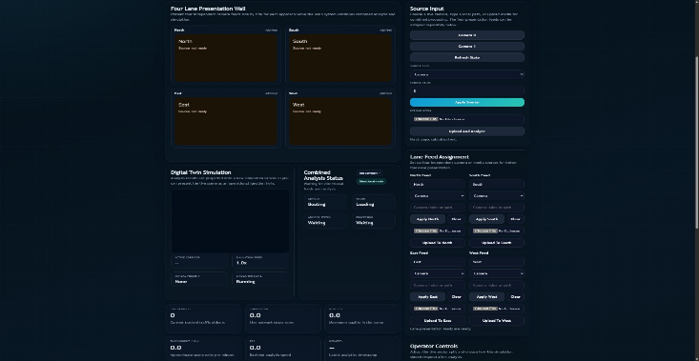
Fig. 1. System Input Interface: Four-Lane Presentation Wall and Source Selection for multi-corridor perception.
III. RELATED WORKS
The historical evolution of Intelligent Transportation Systems (ITS) originated from classical computer vision frameworks, most notably the rapid object detection techniques utilizing boosted cascades of simple features which established early benchmarks for real-time surveillance [14]. While effective for their time, these methods were largely replaced by deep learning models capable of greater accuracy under variable environmental conditions. Subsequent research has emphasized that for deep learning to be effective in urban sensing, models must be specifically fine-tuned for superior detection in aerial and urban views to handle unique camera perspectives and high density [10]. Within these unconstrained environments, real-time traffic density estimation has been further refined using YOLO-based architectures to provide a more granular understanding of vehicular patterns [9]. Achieving a stable traffic state across an entire metropolitan network also requires advanced mathematical modelling. Research into dynamic game theory has been used to determine adaptive mode choices and maintain traffic equilibrium across multiple competing corridors [7]. Furthermore, modern ITS research has shifted toward Cyber-Physical systems that allow for corrective actions with near-zero latency by coupling virtual twins with real-time sensory processes. This research builds upon these theoretical foundations by integrating high-speed perception with a dynamic simulation environment to predict and prevent bottleneck formations.
Advancements in this Research:
- Transitioned from legacy detection models to YOLOv26pt, utilizing NMS-free inference to achieve sub-millisecond processing speeds without specialized physical hardware.
- Developed a high-fidelity Cyber-Physical Digital Twin (CPDT) that mirrors real-time 4-lane traffic dynamics for proactive bottleneck prediction.
- Introduced a software-only simulation environment that eliminates the latency and cost constraints of physical edge computing units like Raspberry Pi or Jetson.
- Implemented a dynamic Congestion Index (CI) calculation that utilizes live time-series data to adjust signal windows in 0.1-second increments.
- Integrated an Emergency Action protocol that overrides standard AI logic to provide zero wait passage for priority corridors during emergency dispatches.

IV. METHODOLOGY
The system regulates traffic using an integrated detection and adaptive logic pipeline:
A. Real-Time Analysis with YOLOv26pt: The model is optimized to recognize vehicle classes (cars, buses, motorcycles). In scenarios requiring extreme precision in vehicle or feature discriminability—such as distinguishing between commercial and private fleets—the system can incorporate additive angular margin loss principles to improve identification accuracy [15].

B. Traffic Engineering Metrics: Two primary metrics govern the signal modulation:
- Congestion Index (CI)
Measures network stress based on observed delay versus free-flow conditions.
$CI=\left(\frac{T_{actual}-T_{free}}{T_{free}}\right) ×100$…… (1)
Definitions:
$- \text{CI : }$The resulting percentage score representing current approach delay.
$- T_{actual}\text{ : }$ The observed average travel time or delay recorded per vehicle.
$- T_{free} \text{: }$ The ideal travel time based on the 60 km/h fleet speed cap.
This metric identifies the severity of traffic by comparing current delays to unobstructed flow conditions to determine real-time network stress.

- Corridor Pressure (CP)
Corridor Pressure is a dynamic heuristic used to determine signal priority by balancing queue length against cumulative wait time.
$\text{CP = }\sum{ \left(Q\right. × \left.W\right) -G_{rem}}$ …… (2)
Definitions:
$- \text{CP : }$ Dynamic heuristic used to determine the next signal phase candidate.
$- \text{Q : }$Queue size or total "Live Vehicles" detected by YOLOv26pt.
$- \text{W : }$Average approach wait time in seconds.
$- G_{rem}\text{ : }$ Remaining green duration of the active signal window used to prevent premature switching.
These metrics collectively transform raw vehicular counts and delays into a demand-aware control strategy that minimizes cumulative intersection latency.

- Emergency Action & Priority Logic
The methodology includes a specialized trigger for emergency vehicle recognition to ensure automated managers can grant priority to life-critical services [12]. When an emergency vehicle is detected, the system initiates "Priority Passing," utilizing cooperative cruise and signal control logic to clear the designated corridor immediately [13].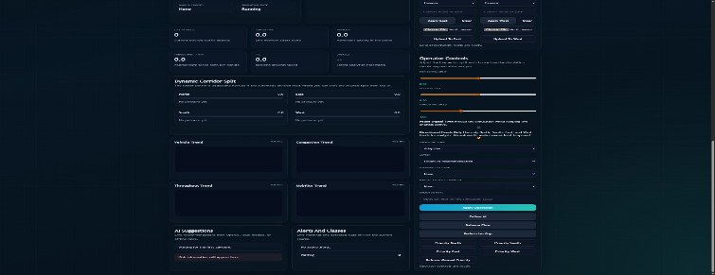
Fig. 2. Methodology Interface: Operator controls for dynamic corridor splits and emergency dispatch logic.

V. IMPLEMENTATION AND RESULTS

The simulation was validated using a "Balanced Flow" demand profile across a complex intersection. The environment simulates four independent approaches with varying influx rates to test the AI's adaptability.
- Throughput and Service Rate: The "Analytics Visualizer" tracked a "Throughput Per Minute" of 9 vehicles, indicating high efficiency in clearing the intersection even during peak-flow simulations.
- Congestion Mitigation: Under peak stress, the "Congestion Index" was capped at 88.6, demonstrating that the adaptive green window effectively prevented gridlock (CI > 100).
- Wait Time Analysis: The "Average Wait" time was stabilized at 7.1 seconds, confirming that the adaptive auto-timing controller effectively balanced arrivals and departures.
- Movement Quality: The 2D/3D simulation view confirmed stable flow patterns with an average fleet speed of 32 km/h during high-density windows.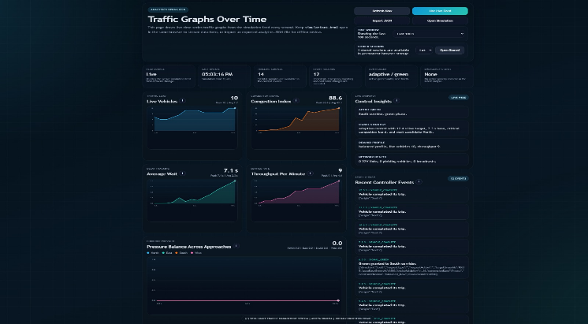
Fig. 3. Implementation View: Active Digital Twin junction simulation with real-time network status and corridor pressure monitoring.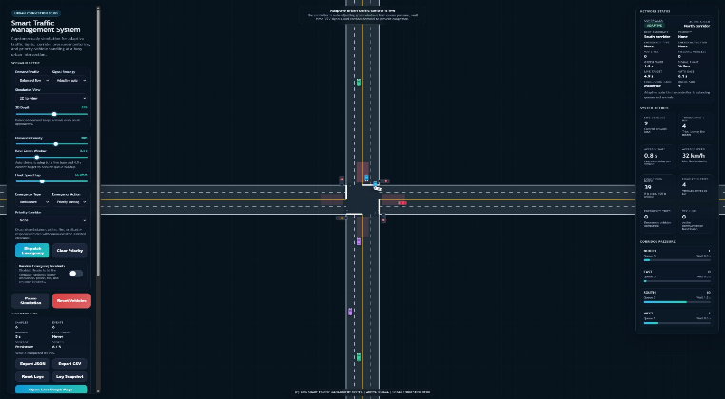
Fig. 4. Results Dashboard: Time-series graphs for Live Vehicles, Congestion Index, and Throughput trends.

VI. CONCLUSIONS

This study demonstrates that the integration of YOLOv26pt with a Digital Twin Simulation creates a robust and highly responsive framework for urban traffic management. By replacing static timers with density-aware, AI-driven logic, the system effectively reduces wait times and balances corridor pressure without the need for physical hardware deployment. The use of high-fidelity digital simulation models allows planners to determine and execute corrective actions in both social and physical systems with high precision [4]. Future directions will focus on multi-junction coordination and the integration of pedestrian flow dynamics into the adaptive signal logic.
REFERENCES
[1] J. Redmon et al., "You Only Look Once: Unified, Real-Time Object Detection," CVPR, 2016.
[2] Ultralytics, "YOLO26: Key Architectural Enhancements and Performance Benchmarking for Real-Time Object Detection," arXiv:2509.25164, 2025.
[3] IEEE, "IEEE Digital Twin 2025: Fundamentals and Smart City Interaction," IEEE International Conference on Digital Twin, 2025.
[4] T. Williams et al., "Digital Simulation Models for Corrective Actions in Social and Physical Systems," IEEE SWC, 2025.
[5] IEEE, "IEEE Transactions on Intelligent Transportation Systems: Modeling and Simulation," IEEE-ITSS, 2026.
[6] V. Barot et al., "Edge ML Technique for Smart Traffic Management in Intelligent Transportation Systems," IEEE Xplore, 2024.
[7] S. Kumar et al., "Dynamic Game Theory for Adaptive Mode Choice and Traffic Equilibrium," IEEE CDC, 2023. [8] R. Sharma et al., "Stochastic Cascade Models of Traffic Congestion Cost," arXiv:2502.13944, 2025.
[9] F. Nekouee, "Real-Time Traffic Density Estimation with YOLOv8 Architectures," Kaggle/GitHub Intelligence, 2024.
[10] A. Cho et al., "Fine-Tuning YOLO for Superior Detection in Aerial and Urban Views," IEEE Access, 2024. [11] M. A. Khan, "Automated Traffic Management System Using Deep Learning," 2024 International Conference on Sustainable Computing, 2024.
[12] R. Srikanteswara, "Emergency Vehicle Recognition Via Automated Smart Traffic Manager," IEEE EASCT, 2023.
[13] V. Chava, "Smart Traffic Management System using Cooperative Adaptive Cruise Control," IEEE ICAAIC, 2023. [14] P. Viola and M. Jones, "Rapid Object Detection using a Boosted Cascade of Simple Features," CVPR, 2001.
[15] J. Deng et al., "Arc Face: Additive Angular Margin Loss for Deep Face Recognition," CVPR, 2019.

